
DEPARTMENT OF COMPUTER SCIENCE AND ENGINEERING
2026 – 2027 (ODD SEMESTER)
CS2307 – INTERNET PROGRAMMING LAB
Online Quiz Application

Abstract
The Online Quiz Application is a web-based system designed to simplify and automate the process of conducting quizzes, evaluating answers, and tracking student performance. In a traditional classroom quiz, an instructor prepares questions on paper, manually checks each answer sheet, and calculates scores by hand, which is slow and prone to error.
The proposed system, QuizEase, provides a centralized platform where students can browse quizzes by category, attempt a timed quiz with multiple-choice questions, and receive an instantly calculated score along with a question-wise review. Registered students can view their complete quiz history and track their progress over time.
Administrators have a separate login through which they can create quizzes, add or edit questions with four options and a marked correct answer, and monitor student attempts. The admin dashboard also displays statistics such as total quizzes, total questions, registered students, and overall quiz attempts.
The system is developed using HTML5, CSS3, JavaScript, PHP, and MariaDB. XAMPP is used as the local development environment, and phpMyAdmin is used to manage the database. PHP handles server-side processing and score calculation, while MariaDB stores student, quiz, question, and result information.
The main purpose of the project is to provide a simple, fast, and accurate way for students to test their knowledge, while giving administrators an efficient way to build quizzes and monitor performance.

Introduction
Assessment is a core part of learning, and the way quizzes and tests are conducted has changed rapidly with the growth of web technology. A traditional paper-based quiz depends on a physical answer sheet, manual checking by the instructor, and delayed feedback to the student. This process is slow, difficult to scale to a large class, and leaves room for calculation errors.
An online quiz platform solves these problems by letting a student attempt a quiz from any device, receive the score immediately after submission, and review which questions were answered correctly. On the instructor side, an online platform gives a single organised place to create quizzes, manage a question bank, and analyse how students are performing, instead of maintaining separate answer sheets and mark lists.
The Online Quiz Application (QuizEase) proposed in this project is a role-based web application built around two kinds of users. A student can register, browse quizzes by category, attempt a timed quiz, and view an instant, auto-graded result. An administrator creates quizzes, adds multiple-choice questions with the correct answer marked, and monitors overall quiz activity.
The system is built with HTML5, CSS3, and JavaScript on the front end for structure, styling, the countdown timer, and client-side interaction, and PHP with a MariaDB database on the back end for authentication, score calculation, and data storage. XAMPP is used to run Apache and MariaDB locally, and phpMyAdmin is used for database administration during development.
This report describes the objectives, modules, design approach, and implementation of the system, followed by screenshots of the working application, references used during development, and a conclusion summarising the outcome and possible future enhancements.

Objectives of the Project
The main objective of this project is to develop a simple and efficient web-based quiz platform.
Primary Objectives
- To develop an online system for attempting subject-wise quizzes.
- To provide separate login facilities for students and administrators.
- To allow students to attempt a timed, multiple-choice quiz.
- To automatically calculate and display the score after submission.
- To allow students to review their past quiz results.
- To allow administrators to create quizzes and manage questions.
- To allow administrators to monitor student attempts and performance.
Secondary Objectives
- To provide a simple and user-friendly interface.
- To maintain category-wise and difficulty-wise quiz listings.
- To provide a live countdown timer during a quiz attempt.
- To prevent a quiz from being submitted more than once per attempt.
- To restrict quiz and question management to authorized admin users.
- To provide a foundation that can be expanded in the future.

Modules Description
The system is organised into the following functional modules, each responsible for a distinct part of the quiz workflow.
4.1 Login Module
The login module provides separate login access for:
- Students
- Administrators
Users enter their login credentials and are redirected to their respective dashboards.
4.2 Student Module
Students can:
- Login / Register to the system.
- View their profile.
- Browse quizzes by category and difficulty.
- Attempt a timed multiple-choice quiz.
- View their instant score after submission.
- Review correct and incorrect answers.
- View their past quiz history and results.
- Logout from the system.
4.3 Quiz Module
This module stores and displays quiz information such as:
- Quiz title and category
- Difficulty level (Easy, Medium, Hard)
- Number of questions
- Time limit
4.4 Question Module
The question module allows the administrator to:
- Add a question with four options.
- Mark the correct option.
- Edit or remove an existing question.
- Assign a question to a specific quiz.

4.5 Result Module
The result module stores:
- Student
- Quiz attempted
- Selected answers
- Score and percentage
- Pass / Fail status
The system automatically calculates the score by comparing selected answers with the correct answers stored for each question.
4.6 Admin Module
Administrators can:
- Login to the system.
- Create, update, or remove quizzes.
- Add, edit, or remove questions.
- View all student attempts and scores.
- View platform statistics such as total quizzes, questions, and students.
4.7 Database Module
MariaDB is used to store:
- Student details
- Admin details
- Quiz details
- Question and option records
- Result records

Methodology / Approach
The project was developed using a structured web application development approach.
5.1 Requirement Analysis
The requirements of the quiz system were identified first.
Student Requirements
- Login / Register
- View profile
- Browse and attempt quizzes
- View instant results
- View result history
- Logout
Admin Requirements
- Login
- Manage quizzes
- Manage questions
- View student results
- Logout
5.2 System Design
After identifying the requirements, the application was divided into different modules.
Online Quiz System
│
┌─────┴─────┐
│ │
Student Admin
│ │
↓ ↓
Attempt Manage
Quiz & Quizzes &
View Score Questions
5.3 Database Design
A relational database was created using MariaDB.
The database contains:
quizease_db
│
├── students
├── admin
├── quizzes
├── questions
└── results
Primary keys and foreign keys are used to maintain relationships between tables.
5.4 Front-End Development
HTML5 was used to create the structure of the pages.
CSS3 was used for:
- Page layout
- Navigation
- Forms
- Buttons
- Question cards and progress bar
- Responsive design
JavaScript was used for the countdown timer, option selection, and client-side validation.
5.5 Back-End Development
PHP was used for server-side processing.
PHP handles:
- Login and registration authentication
- Sessions
- Database connection
- Question retrieval
- Answer submission and score calculation
- Result storage
- Logout
5.6 Database Connectivity
PHP connects to MariaDB using the mysqli extension.
The database connection contains:
Host : localhost
Username : root
Password : empty
Database : quizease_db
Port : 3306

5.7 Testing
The application was tested using different scenarios.
Test Case | Expected Result
Valid student login | Student dashboard opens
Invalid student login | Error message displayed
Valid admin login | Admin dashboard opens
Attempt quiz within time limit | Score calculated and displayed
Timer reaches zero | Quiz auto-submits
Submit quiz with unanswered questions | Unanswered marked incorrect
Admin adds a new question | Question saved to quiz
Admin views student results | Result list displayed
Student views result history | Past attempts displayed
Logout | Session terminated

Implementation Code
Database Connection – db.php
<?php
$host = "localhost";
$user = "root";
$password = "";
$database = "quizease_db";
$port = 3306;

$conn = new mysqli(
$host,
$user,
$password,
$database,
$port
);

if ($conn->connect_error) {
die("Database connection failed.");
}
$conn->set_charset("utf8mb4");
?>

Student Login — login.php
<?php
session_start();

$stmt = $conn->prepare(
"SELECT student_id, name, email
FROM students
WHERE email = ? AND password = ?"
);
$stmt->bind_param("ss", $email, $password);
$stmt->execute();
$result = $stmt->get_result();

if ($result->num_rows > 0) {
$_SESSION['role'] = "student";
header("Location: student_dashboard.php");
} else {
echo "Invalid Login";
}
?>
Fetch Quiz Questions — attempt_quiz.php
<?php
$quiz_id = $_GET['id'];

$stmt = $conn->prepare(
"SELECT question_id, question_text,
option_a, option_b, option_c, option_d
FROM questions
WHERE quiz_id = ?"
);
$stmt->bind_param("i", $quiz_id);
$stmt->execute();
$questions = $stmt->get_result();
?>

Submit Quiz & Calculate Score — submit_quiz.php
<?php
session_start();
$student_id = $_SESSION['student_id'];
$quiz_id = $_POST['quiz_id'];
$answers = $_POST['answers'];
$score = 0;

foreach ($answers as $question_id => $selected) {
$stmt = $conn->prepare(
"SELECT correct_option FROM questions
WHERE question_id = ?"
);
$stmt->bind_param("i", $question_id);
$stmt->execute();
$row = $stmt->get_result()->fetch_assoc();

if ($selected == $row['correct_option']) {
$score++;
}
}
?>
Save Result — save_result.php
<?php
$sql = "INSERT INTO results
(student_id, quiz_id, score, total_questions, status)
VALUES (?, ?, ?, ?, ?)";

$stmt = $conn->prepare($sql);
$stmt->bind_param("iiiis", $student_id, $quiz_id, $score, $total, $status);
$stmt->execute();
echo "Result saved";
?>
Admin — Add Question
<?php
$sql = "INSERT INTO questions
(quiz_id, question_text, option_a, option_b,
option_c, option_d, correct_option)
VALUES (?, ?, ?, ?, ?, ?, ?)";

$stmt = $conn->prepare($sql);
$stmt->bind_param("issssss", $quiz_id, $question_text,
$option_a, $option_b, $option_c, $option_d, $correct_option);
$stmt->execute();
echo "Question added";
?>

Screenshots
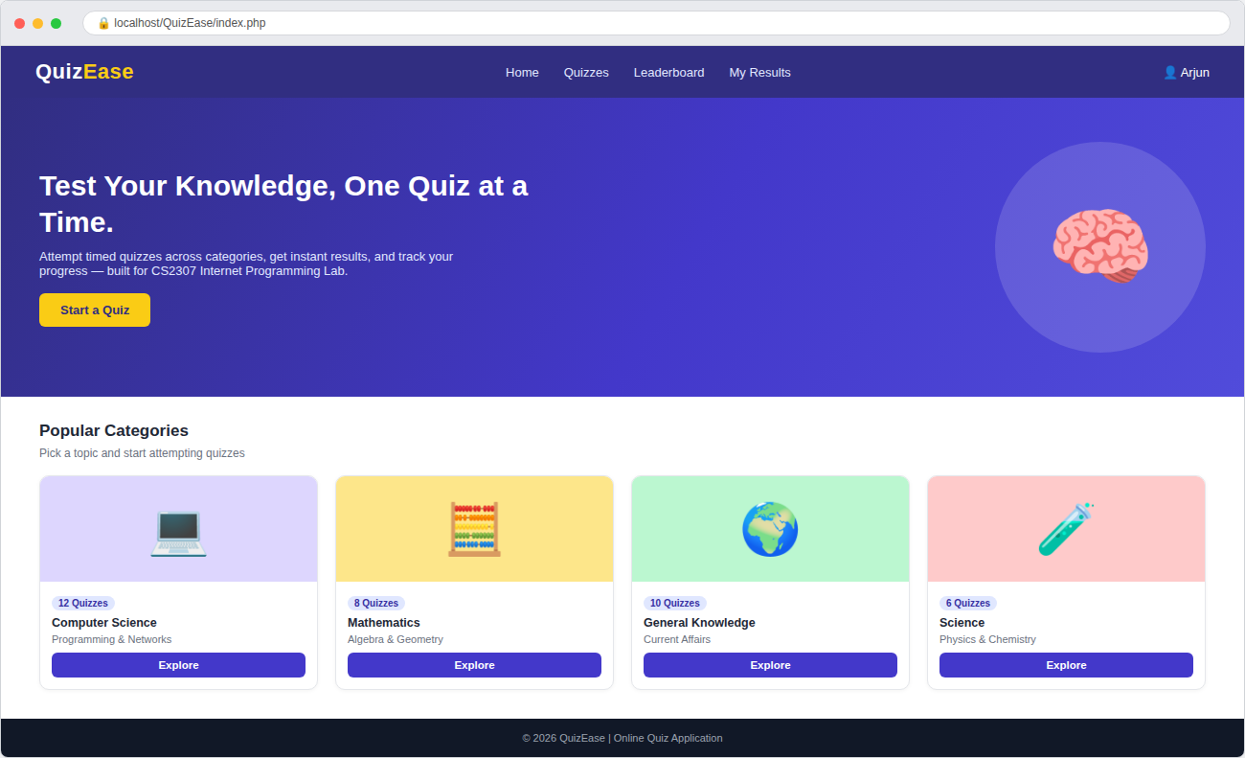
Popular quiz categories

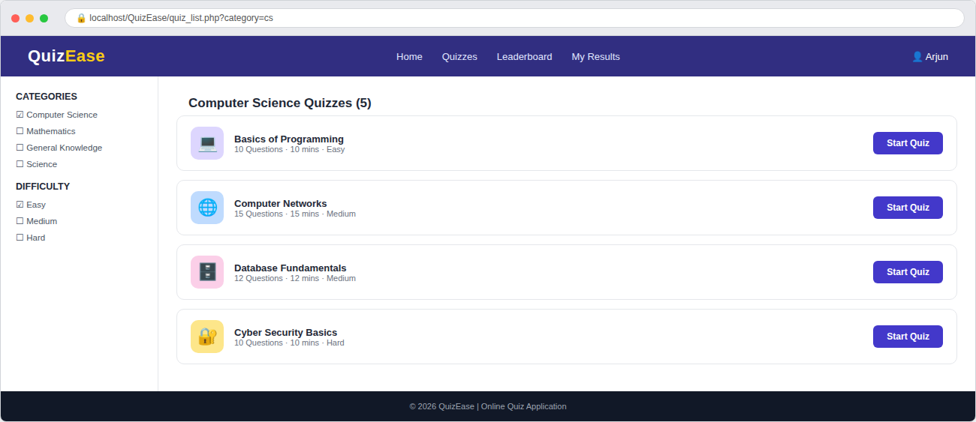
Category and difficulty filters

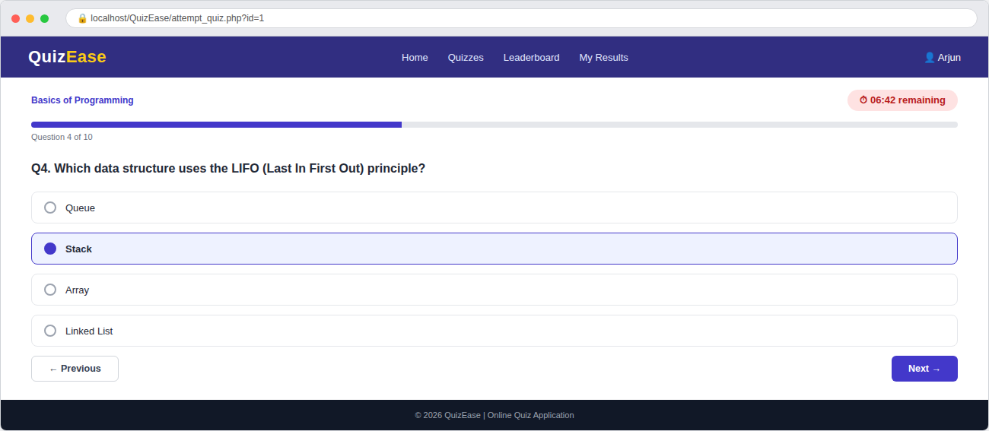
Question, options, timer, and progress
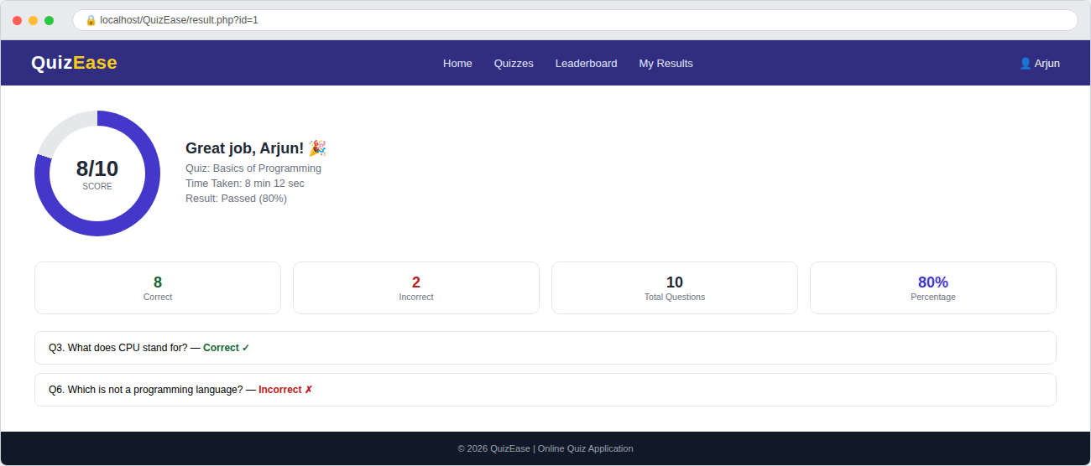
Score summary and answer review

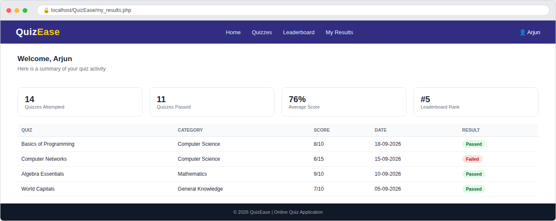
Student quiz history and statistics

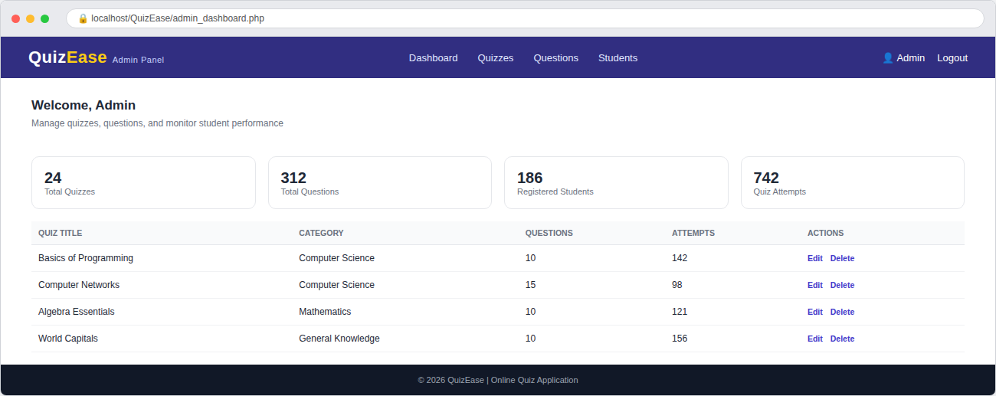
Quiz management and platform statistics

References
The following resources were used for understanding and implementing the technologies used in the project:
- PHP Documentation – PHP syntax, sessions, forms, and MySQLi database connectivity.
- MariaDB Documentation – Database creation, SQL queries, tables, keys, and constraints.
- MDN Web Docs – HTML – HTML elements and web page structure.
- MDN Web Docs – CSS – CSS styling and responsive design.
- MDN Web Docs – JavaScript – JavaScript programming and client-side functionality.
- XAMPP – Local Apache and MariaDB development environment.
- phpMyAdmin – Database management and SQL execution.

Conclusion
The Online Quiz Application successfully provides a digital solution for attempting quizzes, calculating scores, and tracking student performance. The system separates the responsibilities of students and administrators through role-based access.
Students can browse quizzes by category, attempt a timed multiple-choice quiz, and instantly view their score along with a question-wise review. Administrators can create quizzes, manage the question bank, and monitor student attempts through a dashboard.
The use of PHP and MariaDB provides an effective server-side and database solution, while HTML, CSS, and JavaScript provide the user interface and countdown timer. XAMPP makes it possible to develop and test the application locally.
The system reduces manual checking, avoids calculation errors, provides organised records, and allows quiz results to be accessed instantly. The project can also be extended in the future with features such as a leaderboard, question randomisation, negative marking, downloadable certificates, and cloud deployment.
Project URL
Local Project URL:
http://localhost/QuizEase/
This URL can be used to access the project when Apache is running in XAMPP.

